Data Flow Diagram & User Stories

Date | 8/3/2026
Team ID | 699ee184888d5941317809a8
Project Name | Malaria Detection with deep learning
Maximum Marks | 2 Marks

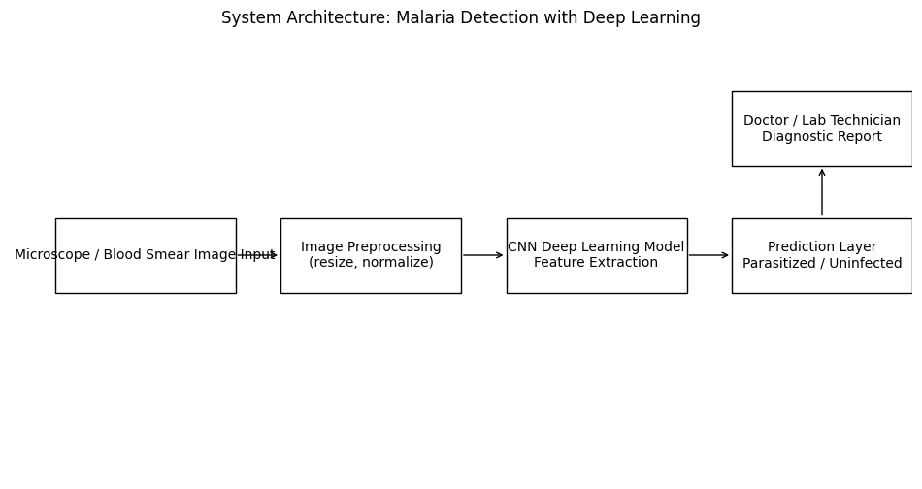

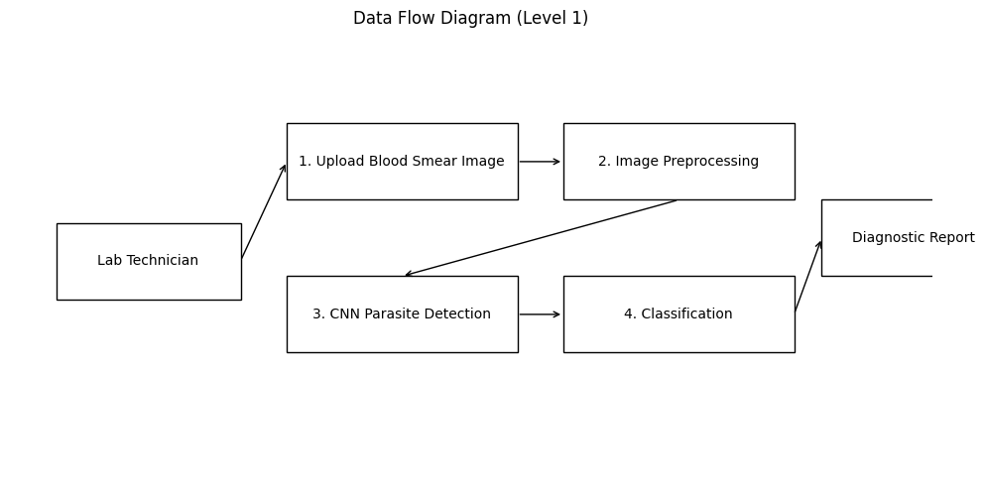
User Type | Functional Requirement (Epic) | User Story Number | User Story / Task | Acceptance Criteria | Priority | Release
Lab Technician | Image Upload | US-1 | As a lab technician, I want to upload blood smear images so the AI system can analyze them. | Image uploads successfully and preview appears. | High | Sprint-1
Lab Technician | Malaria Detection | US-2 | As a lab technician, I want the system to automatically detect malaria parasites. | System processes image and displays infected/uninfected result. | High | Sprint-1
Doctor | View Diagnostic Report | US-3 | As a doctor, I want to view diagnostic reports to confirm malaria diagnosis. | Report generated with classification result. | High | Sprint-1
Healthcare Worker | Verify AI Results | US-4 | As a healthcare worker, I want infected cells highlighted so I can verify AI predictions. | Detected parasite regions highlighted on image. | Medium | Sprint-2
Administrator | System Monitoring | US-5 | As an administrator, I want to monitor system performance and stored results. | System dashboard shows analysis statistics. | Medium | Sprint-2

